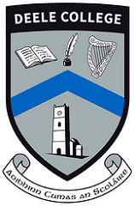

Raphoe Technical / Vocational School

Deele College
Percent for Art Opportunity
2016

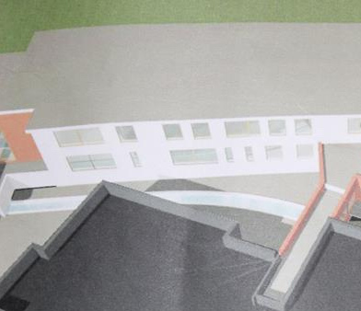
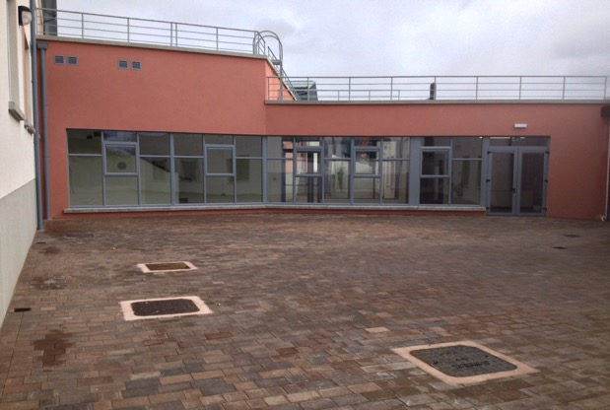
Donegal Education and Training Board (Donegal ETB) and Deele College intends to commssion a site specific public artwork under the Per Cent for Art Scheme, funded by the Department of Education and Skills.
The artwork should animate our new area adjacent to the glass corridor which links our existing building to our new extension.

We particularly welcome proposals that connect to the themes of care and respect for our natural environment, the importance of recycling, and the rich heritage of Raphoe which includes a Neolithic Stone Circle, Ecclesiastical and Georgian Architecture. The proposals should outline how the project will include during September 2016 a period of consultation and collaboration by pupils in our art department. We will require the commission to be completed during our Autumn term 2016.

Corridor – approximately 14.5 metres left to right
Space - approximately 22 metres x 14.5 metres

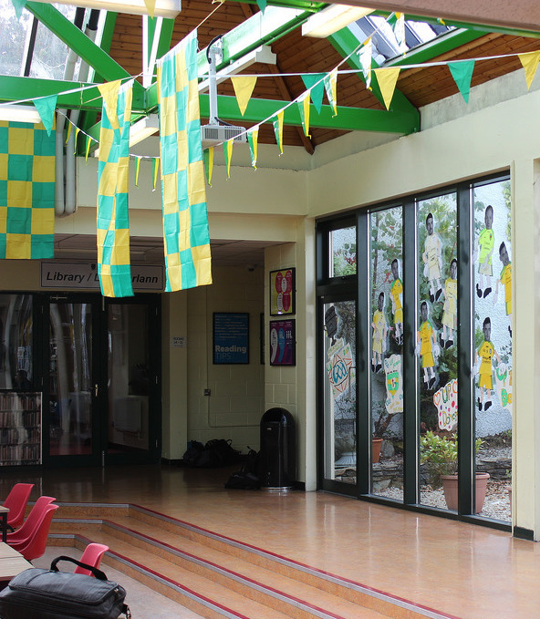
Situated in the heart of Raphoe, Deele College, a DEIS school, has a wide catchment area, covering eighteen feeder primary schools and operates under the aegis of Donegal Education and Training Board. The school was first established in 1965 under the agency County Donegal Vocational Education Committee (now Donegal Education and Training Board). A major extension was construed at the School in 1985 to cater for 420 students. There are currently 520 students attending the school and the enrolment each year is increasing. Our new extension opened in April 2016 and it includes new science laboratories, a Design and Communications Graphics Room, new Home Economics rooms, Music/Drama and Arts & Crafts facilities and extra space for Learning Support, Guidance and Pastoral Care, with the addition of a new fitness suite, a multimedia learning laboratory and new IT suites, equipped with the latest technology, all that is needed in terms of technology in the 21st century.

Local context: Raphoe

Raphoe is a small town situated on the lower slopes of Mongorry Hill in the fertile area of East Donegal known as 'The Laggan'. The name is most likely derived from the Irish 'lag' or 'lug' which means a flat or hollow place. Raphoe derives it's name from 'Rath Bhoth' meaning 'Ringfort of the Huts'. The early monks constructed their huts from clay and wattle and surrounded them with a strong fortified mound.
Raphoe is regarded as 'The smallest cathedral city in Europe' and this appears to date back to a petition dated July 15, 1600 to Pope Clement the Eighth from the city of Raphoe. Although originally a monastic settlement, Raphoe is now essentially a Plantation Town. The scheme for plantation placed a heavy emphasis on the importance of urban settlement. The town was a large nucleated settlement which provided service facilities such as a Church, School, Inn or "Tap-House" and, in particular a weekly market. Raphoe was one of 25 original sites designated to be corporate towns by the plantation commissioners in 1609. The focal point of the plantation town was the market place or "Diamond". The 'Diamond' does not refer to the shape of the marketplace. It can follow any plan, although all occur at road intersections. A patent to hold fairs was granted to Bishop Andrew Knox in 1630. The Market House, built in 1874, with the purpose of collecting toils from farmers on fair days once stood in the centre of the Diamond.
Raphoe was designated a 'Heritage Town' by Donegal County Council in 2000 and contains several fine examples of ecclesiastical and Georgian architecture. The rich agricultural land around Raphoe has been inhabited and cultivated for thousands of years, and evidence of this can be seen through monuments such as the Beltany Stone head (most likely a Celtic God) which is held in the collection of the National Museum in Dublin, and Beltany stone circle, just outside the town. The stone circle is one of the largest in Ireland with a diameter of 44 metres (165 feet) and made up of more than sixty stones in all. The site is believed to date to around 2000 BC, and that it was originally an enclosed cairn. Its name is believed to be linked to the Celtic festival of fertility known as 'Beltane'.

Commissioning Process
This is a two stage open commission and will be managed by Deele College and Donegal Education and Training Board.

The commission is open to all professional artists. Selection will be made by a representative group from the school including the Principal, Staff, Parents and a Professional Curator.

Budget: €23,000 ( inclusive of all artists’ fees and costs including installations, VAT, insurance etc. )

Stage 1
Artists are invited to express their interest in being considered for this project at the first stage of this commission.
Please submit
• CV
• Images /recordings of previous work
• Letter outlining how you feel your work could relate to the themes mentioned above and
that any subsequent proposal will match our timetable for completion in Autumn 2016.

These should be emailed to deelecollegecommission@gmail.com

Deadline for stage 1 completed application as outlined above – including all supporting documentation and material - is Monday July 18th 2016 at Noon.

Stage 2
From the completed stage 1 applications, a shortlist of not more than five artists will be selected by panel jury. This panel, whose decision is final, has the right to ask for clarification of any issue which may arise in the course of selection. A fee of €200 will be paid to shortlisted artists as further work will be required to prepare a detailed submission including written outline, budget outline, feasible timeline/schedule and visual representation. The shortlisted artists will also be invited to present/develop their proposals in a way that will be easily accessible to staff and pupils.

Site Visits
Site visits will be arranged during summer 2016 for shortlisted artists at Stage 2 of the commissioning process.
Shortlisted artists will be required to submit a Tax Clearance Certificate and be subject to Garda vetting.

Stage Two Schedule and Project Completion
The Stage Two proposals from artists will need to include a draft schedule which includes in September 2016 a period of consultation and collaboaration with pupils (likely to be transition year pupils) from the school and a timetable to complete the artwork in time for the official opening of the new extension in the Autumn 2016 term, likely to be several weeks into the term, final date tbc.

Deele College and Donegal Education and Training Board reserves the right not to proceed with any of the submissions received.
Further information and digital submissions to deelecollegecommission@gmail.com by deadline of Monday 18th July 2016 at Noon.

