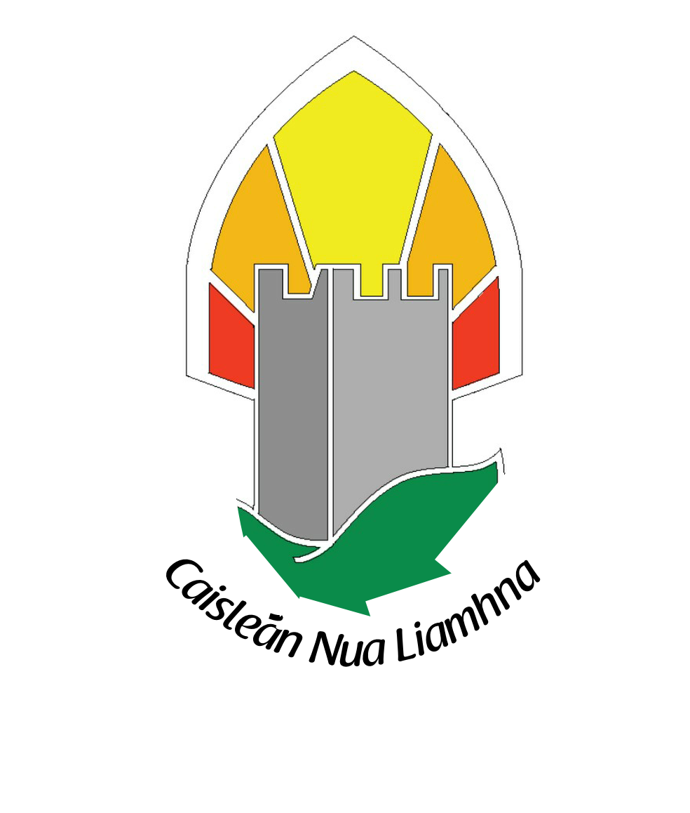
St.Finian’s Primary School

PERCENT FOR ART COMMISSION
Percent for Art Commission – St. Finian’s invite submissions for a Visual Work of Art on the school grounds (fixed, permanent), an external visualwork of art that is child friendly, tactile and visually exciting functional.

St. Finian’s is a co-educational school in Newcastle, Co. Dublin. We have grown in the last few years and our current enrolment is 496 students and growing. We have a fantastic Special Educational building attached to the school that has an ASD class and an MGLD class.
We are very proud of our community and our surroundings and we like to be involved in all aspects of community development.

The aim of the commission is to provide an opportunity for artists to develop new work influenced by the history, context and aspirations of the students, teachers, parents and community of the school and the surrounding area. This building project heralds an exciting new beginning for St. Finian’s National School and the commission should reflect that. In order to convey a sense of the wonderment of children the following key words convey the message we are hoping to send through this piece of art:

Renewal, regeneration, growth, awe of childhood, sport, continuity, music, friendship between children, schools and community, relationships, pride and a sense of history.

Brief:
The Commissioners require this visual work of art to represent the school’s rich cultural heritage and be located in the school grounds. The exact location has yet to be decided. The commssioners would like the work of art to have a function. (Seating area, outdoor classroom)

The total budget for the Commission is €38,000.
The Commissioning Process:

The selection process will take the form of a Two Stage Open Competition. It is open to all interested professional artists at any stage of their career or experience. Selection will be based on the information supplied, establishing the competence of the artists to carry out this commission. No designs or detailed proposals are required in Stage 1.

Stage 1
Artists are invited to express their interest in being considered for this project at the first stage of this commission. Artists may do this by completing the application form and submission of a CV and images / details of recent relevant works / projects. The closing date for receipt of Stage 1 completed application form together with supporting documentation and material is June 2nd 2017 @ 12pm.

Stage 2
From the completed Stage 1 applications; a shortlist of artists will be selected by panel jury. This panel, whose decision is final, has the right to clarify any issue which may arise in the course of selection. Stage 2 short listed artists will be paid a minimum concept development fee of €200 to work on a detailed proposal for final selection. A Stage 2 brief will be available to shortlisted artists and a site visit is expected at this stage. St. Finian’s reserves the right not to proceed with any submissions received.

Selection Panel:
It is proposed that the selection panel will consist of the Principal, City Arts Officer, Professional Artist, 2 nominees each from the Board of Management, Staff and Parents Committee.

Project Delivery Timeline:
Please provide an approximate provisional timeline for the project. The final timeline will be agreed with the commissioned artist at contract stage.

Budget:
The total budget for the project is €38,000 (inclusive of all related costs). This includes the costs of any materials, artist’s fees, design development, artists’ insurance, supply and installation, signage, travel, and any other costs incurred in the production of the project / artwork. The artist will be responsible for meeting all of these costs out of the total budget allocated.
Site Location:
St. Finian’s National School, Main St. Newcastle, Co. Dublin

Site Visits:
Site visits will be arranged for shortlisted artists at Stage 2 of the commissioning process. Site drawings will also be made available to shortlisted artists.
Queries:
Applicants can make enquiries regarding the commission (reference Per Cent for Art Commission in subject line) to:info@stfiniansprimaryschool.ie or 014580114

Guidelines:
It is recommended that you read these guidelines and supply supporting documentation and material by email as requested.
1. Include a current CV
2. Include the best examples and reproductions of your work/working practice that best demonstrate your experience for this commission. Please do not send original artworks.
3. Please complete the application form clearly in ink or type.
4. Include a stamped addressed envelope for return of your application.
5. Keep a copy of your application for reference purposes

Percent for Art Commission
St. Finian’s NS, Newcastle, Co. Dublin
Stage 1 – Application Form
Name of Artist: __________________________________________________
Contact Address: (please note all correspondence will be sent to this address) ___________________________________________________________________
___________________________________________________________________
Telephone:______________________ Email: ____________________________
- Please give short description of your art practice in its relevance to this project:

2) Artists are asked to submit the following:

a. Detailed Curriculum Vitae
b. List of previous relevant projects or commissions, cost, time scale to deliver, list of specialist or other contractors engaged by the artist in connection with the completion of these installations
c. Visuals of previous work
d. Names of referees and their contact details
e. Confirmation that if successful the artist is ready to submit current Tax Clearance Certificate / Number and provide insurances. This confirmation is mandatory.

3) Supporting Documentation:
To assist in the assessment of your application, supporting documentation should be included and should be submitted and it must be clearly labelled:

Supporting documentation | Number of Items Enclosed | Enclosed (please tick)
CV

Stamped addressed envelope (SAE)
CDs/DVDs

Other, please specify

Freedom of information:
Applicants completing this form should note that information provided to St. Finian’s may be disclosed in response to a request made under the Freedom of Information Act (1997 and 2003). Every effort will be made to protect client confidentiality.
Garda Vetting:
The successful artist will be subject to Garda vetting procedures
Declaration:
I have read the award conditions, agree to be bound by them, and certify that the information in this application is correct to the best of my knowledge.
Signed: ____________________________________
Date: ____________________________________

This application form and supporting information should be returned HARD COPY to the address below:
Per Cent For Art Commission
FAO Jonathan Loftus,
St. Finian’s NS ,
Main St,
Newcastle,
Co. Dublin
Closing date for the receipt of completed applications is June 2nd 2017 @ 12pm.
Please note that applications received after the closing date and time will not be accepted. Emailed applications cannot be accepted.

.

