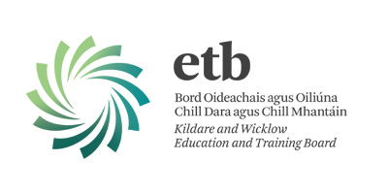
Kildare and Wicklow Education and Training Board
Public Art Commission
located at
Glenart College, Arklow, Co. Wicklow
Funded by the Department of Education and Skills under the Per Cent for Art Scheme

The closing date for tenders is 12:00 noon on Submissions to;
Friday, 6th January, 2016 Seán Ashe, Chief Executive
Late submissions will not be accepted. Kildare and Wicklow ETB
Budget: €48,000 Church St. Wicklow Town A67 A971

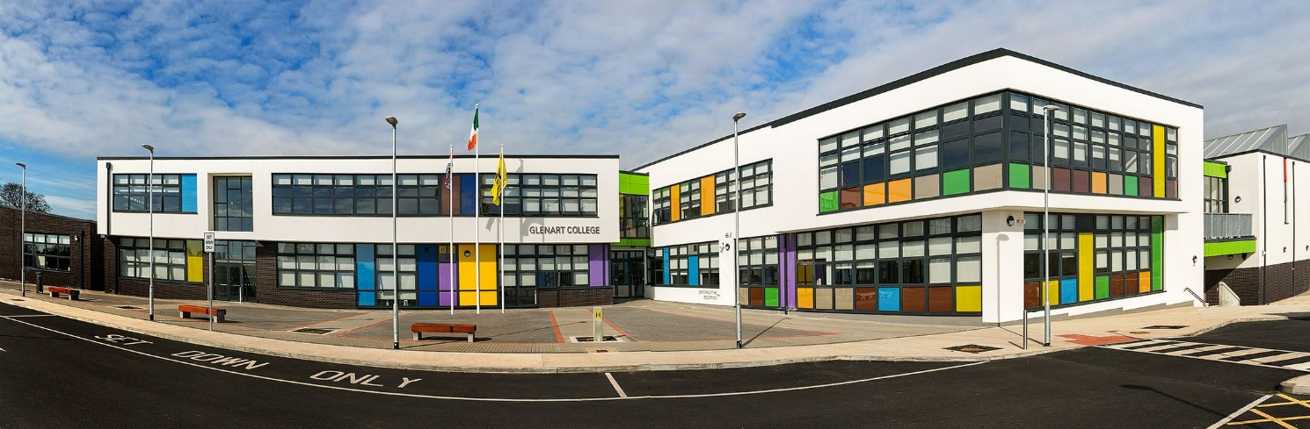

Applicants are requested to read the full contents of this document as it contains important information about the Application and Selection Process.
- Background - Glenart College, Arklow, Co. Wicklow

Glenart College is a second level multidenominational mixed school which operates under the management of Kildare and Wicklow Education and Training Board.
From its inauguration in 1905 when classes were organised in the local courthouse, Arklow Community College (now Glenart College) has had a very firm commitment to change and development. From the seedling that was sown many years ago when there was an initial enrolment of 56 students and a very narrow range of subject disciplines, it has grown to an institution currently catering for over 300 students including adults, serviced by a curriculum of twenty six different disciplines.
The school found its first permanent home in 1915 on St. Mary’s Road. This building was to be the home of vocational education in Arklow until the 1970’s when growing demand for second level education caused an upsurge in numbers. In 1974 the school was opened on the Coolgreaney Road and was extended in 1979. A new state of the art building catering for 710 students was opened in September 2015 on the existing site and the old school building was demolished.
- School Building Design
The overall design of the building was evolved after a series of design charrettes, and the main elements of the design are as follows:
- The main northern spine of the building is a large cranked block that steps down to follow the contours of the site. This block forms the main body of the building, and from this the secondary elements are attached. This spine has a wide circulation core running along its length, and forms the ‘main street’ of the building. This main spine cranks towards Coolgreaney road, and at first floor level, a large projecting bay window in the library frames the view from the school towards the sea.
- From this spine, 2 distinct 2 storey elements are connected perpendicularly to form ancillary accommodation. These blocks are secondary to the main spine, and hence read as smaller blocks.
- The technical block is a single storey element that encloses the courtyard to the south of the building. Architecturally, this lessens the scale of the building, and also fulfils the acoustic and ventilation requirements of the technical block.
- The main spine element is a solid white mass with ribbon windows with coloured spandrel panels, with the secondary element as white mono-pitched forms cantilevered over dark brick plinths. The technical block bookends the building in a dark brick.
- The PE Hall is the most expressive element of the building, with a large saw tooth roof and north facing rooflights, bringing light deep into the space with no glare.
- The main entry to the school is defined by a large courtyard and is at one of the junctions of the spine and secondary wing, and one immediately enters into the main social space of the school. From this point all spaces within the school are easily navigated to. The junction between the spine and the secondary wing to the north forms the other main node within the school building.
- All of the corridor spaces are filled with light, and all corridors have breakout social spaces at junctions with other elements.

Artists’ Brief
A permanent artwork is required which will enhance the school building and which will enrich the daily experience of the school community including students, staff, parents and the visitors to the school.
The theme of the artwork should be to represent student(s) striving to reach their potential, both personal and academic and teacher(s) helping them to reach that potential.
The Artist is required to create an original artworks that is permanent, durable, easily maintained and secure. The artwork should be distinctive, interesting and complement the wonderful design of the new school building.
The commissioned artist must be experienced in delivering complete projects and must demonstrate their ability to project manage the project from start to finish.
Possible locations are to the front of the building and/or the wall of the bay window. But all proposals will be considered.
Site Visit
Artists can avail of a site visit by contacting the school directly at
Tel: 0402 32149 or Email: glenartcollege@kwetb.ie

- Eligibility
The successful artist will be required to;
  - Produce promptly a valid tax clearance certificate or C2 certificate from the Revenue Commissioners if commissioned for an art installation or be in a position to provide a statement of suitability on tax grounds from the Revenue Commissioners in Ireland, in the case of a non-resident candidate.
  - Hold for the term of the Art Contract the following insurances
ii) Employers Liability Insurance
    - Public/Products Liability Insurance (€6.5 million)

- Submission Stage 1

Artists should submit the following;
- An up to date typed Artist’s Curriculum Vitae (C.V)
- An outline proposal and concept for the project
- Examples of previous work undertaken in the last 10 years which have particular relevance for this project. This can be submitted on USB or CD if more convenient.
- Breakdown of budget and estimated time scale for completion.
- Name, address and telephone number of two referees who may be contacted in relation to previous projects; KWETB reserve the right to contact all clients in relation to previous work examples.

Submissions marked “Glenart- Public Art” should be returned to;

Mr. Sean Ashe,
Chief Executive
Kildare and Wicklow Education and Training Board
Church Street
Wicklow Town A67 A971

No later than 12 noon, Friday, 6th January, 2016
Queries in relation to the competition can be directed to Carmel Whelan Email:carmelwhelan@kwetb.ie or Tel: 0404 60532
- Evaluation of proposal
A Shortlist of artists will be selected by the evaluation panel to go forward to Stage 2 and will be given a honorarium of €300.00 to develop their proposals further.
Selection criteria;
Artistic Merit
Innovation of the concept
Adherence to the theme
Previous experience / demonstrated ability to carry out the project
Value for money
Clarity, practicality of the proposal
- Budget

The successful artist/design team will be responsible for the design and creation of the artwork and delivery/installation. The proposed budget of €48,000 will include all artists design fees, expenses, foundation costs, materials, insurances, production and manufacturing, engineer’s reports, and installation fees, transport costs, and other necessary fees in order to finalise the installation of the public art piece. The successful artist will be required to sub-contract and project manage all associated work for the public art piece. The KWETB building Design Team must approve all building associated elements of the proposal.

The overall fee should also include for additional lighting to highlight the sculpture. Artists will be expected to submit an itemised project budget that identifies all costs, including contingencies. It must cover all disbursements, design, documentation, materials, foundation costs, relevant insurances, engineer’s reports and manufacturing and the delivery to the site of the finished artwork and installation. All artists must comply with the necessary Health and Safety Legislation in the manufacture, supply, delivery and installation of the work.

- Conflicts of Interest
Any conflict of interest or potential conflict of interest on the part of an Artist, individual employees, agents, or sub‐contractors of an Artist must be fully disclosed to Kildare Wicklow Education and Training Board as soon as the conflict or potential conflict is or becomes apparent. In the event of any conflict or potential conflict of interest, Kildare Wicklow Education and Training Board may invite Artists to propose means by which the conflict might be removed. Kildare Wicklow Education and Training Board will, at its absolute discretion, decide on the appropriate course of action, which may in appropriate circumstances include eliminating an Artist from the competition or terminating any contract entered into by an Artist.

Employees or former employees of Kildare and Wicklow ETB or former VECs or any other ETB are not eligible to apply for this competition.

- Freedom of Information
Applicants should be aware that, under the Freedom of Information Act 2014 information provided by them during this public procurement competition may be liable to be disclosed.
Applicants are asked to consider if any of the information supplied by them in their submission should not be disclosed because of its commercial sensitivity. If applicants consider that certain information is not to be disclosed because of its commercial sensitivity, applicants should, when providing such information, clearly identify same and specify the reasons for its commercial sensitivity. If applicants do not identify it as commercially sensitive, it is liable to be released in response to a Freedom of Information request without further consultation with you. The Contracting Authority will, where possible, consult with applicants about commercially sensitive information so identified before making a decision on a request received under the Freedom of Information Act.

